Cell Line: ULK1 KO MEF (SV40)
Catalogue Number: 14050807
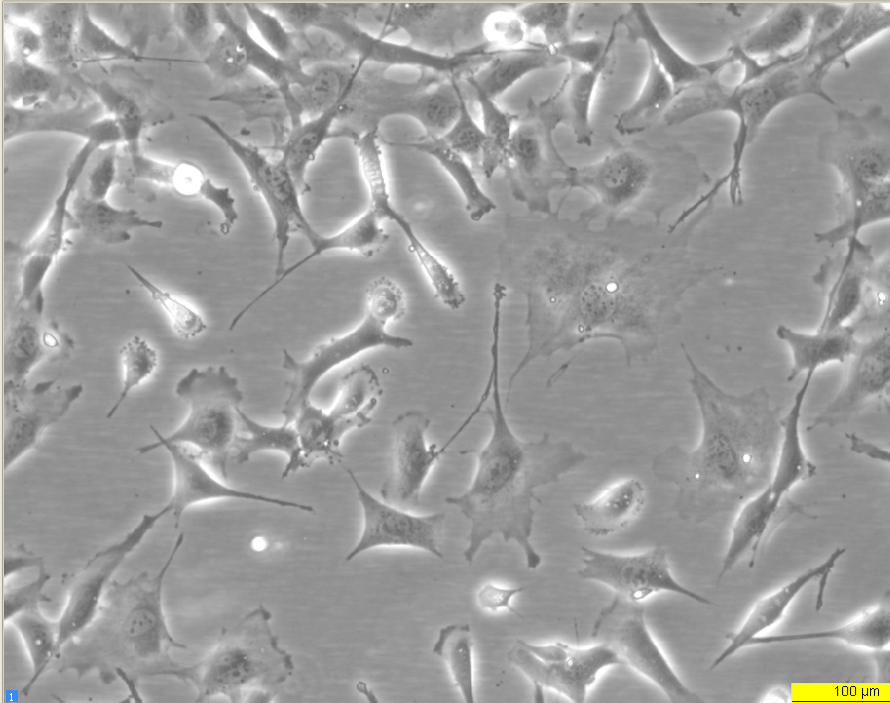
Early log phase 24 hours
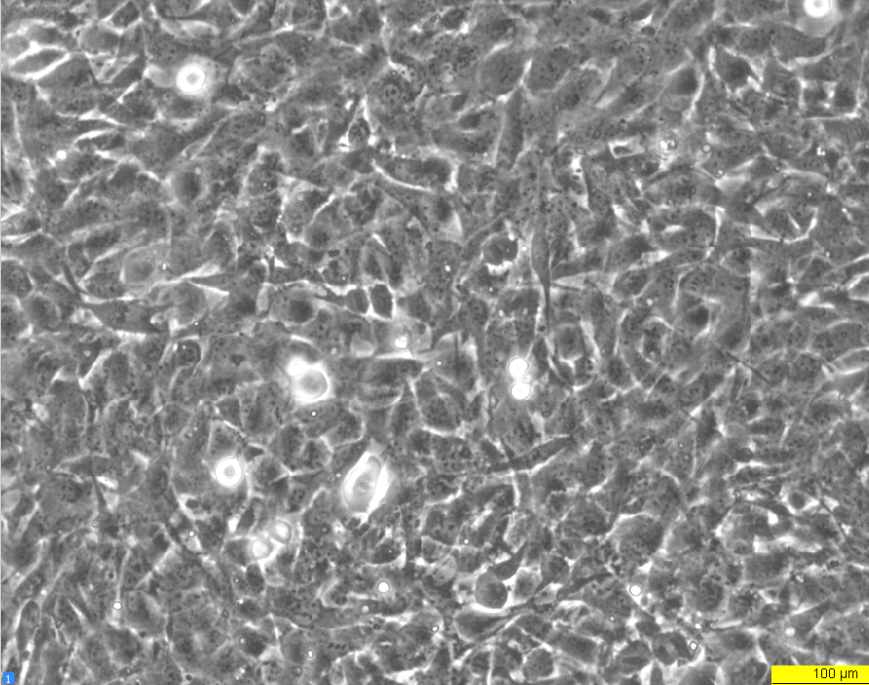
Late log phase 72 hours

